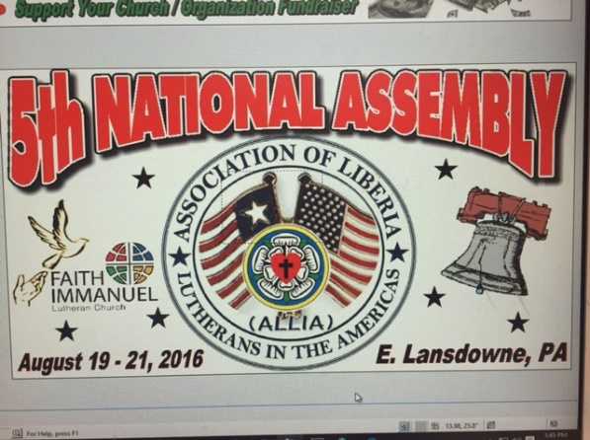Association of Liberian Lutherans in the Americas 65 Penn Blvd. E. Lansdowne, PA 19050 [www.allia.us_267-259-0538](http://www.allia.us_267-259-0538)

**2011-2016 Highlights**

ALLIA was stablished August 13, 2011 by the merger of three predecessor organizations: Association of Liberian Lutherans in the Americas (The Old ALLIA) Philadelphia, PA; Liberian Lutherans in the Diaspora (LLD) Chicago, IL/Minneapolis, MN, African International Lutheran Church (AILC) Columbus, OH. Current LCL Bishop, D. Jensen Seyekulo was a founding member of ALLIA in his capacity as the convener of the LLD.

ALLIA meets annually for National Convention: 2016-Philadelphia, PA; 2015 Baltimore, MD; 2014-scheduled for Kath TX but was cancelled due to Ebola scare, 2013-St. Minneapolis, MN; 2012-Philadelphia, PA 2011-Columbus, OH. Scheduled to meet in Minneapolis, MN Aug. 11-12, 2017.

ALLIA and LCL entered a Memorandum of Relationship at the LCL 2014 Convention. ELCA Pastor and ALLIA member, the Rev. Emmanuel Jackson represented ALLIA and was the guest preacher at that Convention.

Participated in the India Medical Treatment Project of LCL Pastor, Rev. John Sumo in 2013-2014

Rev. Dr. Moses Suah-Dennis in his capacity as the president of ALLIA and the Liberian Ministers Association of the Delaware Valley, PA sent a 40FT Container of Medical, clothing and other supplies to the LCL in June of 2015 as Ebola Relief.

ALLIA plans send a delegation of 5-7 persons to observe LCL 2017 convention. ALIA hope is that the LCL will formally approve LUL proposal at that 2017 convention. ALLIA passed LUL resolution at the Joint Great Gathering of ALLIA and ADLA to partner with the LCL to build a Regional Lutheran University in Liberia. LCL Bishop, the Rev. D. Jensen Seyenkulo and ELCA Bishop Elizabeth Eaton were in attendance at the gathering.

ALLIA agreed to gather donation of medical equipment (drugs/related supplies), non-perishable food items, clergy clothing, hymnals, school supplies (books, uniforms, shoes, and related items) among other things to be shipped early March ahead of ALLIA delegation to Liberia.

ALLIA currently has over 75 members across the US and Canada and a leadership elected at the August 19-21, 2016 Convention.

|  |  |  |  |
| --- | --- | --- | --- |
| FULL NAME | ALLIA Position | Church Affiliation | City/State |
| Rev. Dr. Moses Suah-Dennis | President | Sr. Pastor, Faith-Immanuel Luth Ch. | E. Lansdowne, PA |
| Mr. George Toto | Vice President | Zion Lutheran  ULAA Board Chair | Pittsburg, PA |
| Mrs. Mydea Reeves Karpeh | Secretary | Peoples’ Community Lutheran Church | Baltimore, MD |
| Mrs. Joseph Sumoward Roberts | Treasurer | River of Life Lutheran Church | Minneapolis, MN |
| Rev. Moses B. Gobah | Chaplain | De-MD Synod | Baltimore, MD |
|  |  |  |  |
| **BOD** |  |  |  |
| Mr. Morris Gbolo | Chair | Grace Lutheran Ch. | Summer Point, NJ |
| Mr. Francis Hinneh | Vice Chair | Trinity Lutheran Ch. | Ontario, Canada |
| Rev. Amadu Sirleaf | Member | Faith-Immanuel Lutheran Church | East Lansdowne, PA |
| Mrs. Alice Hinneh | Member | Zion Lutheran Church | Ontario, Canada |
| Mrs. Joyce Adams | Member | Faith-Immanuel Lutheran Church | East Lansdowne, PA |
| Mr. Frank Carter | Member | African International Lutheran Church | Columbus, OH |
| Mr. Murphy Anderson | Member | Grace Evangelical Lutheran | Westerville, OH |
|  |  |  |  |
| **LUL Task Force** |  |  |  |
| Mrs. Mydea Reeves Karpeh | Chair | Peoples’ Community Lutheran Church | Baltimore, MD |
| Dr. Sakui Malakpa | Co-chair | Hope Lutheran Church | Toledo, OH |
| Mrs. Matie Mulbah | Member  LTI US Alumna, | Emmanuel Lutheran Church | Piscataway |
| Rev. M. Amadu Sirleaf | Member | Faith-Immanuel Lutheran Church | East Lansdowne, PA |
|  |  |  |  |